**

**STAFF NICKNAME: STAFF POSITION:** Have each staff member write a 4 to 5 sentence biography in 3rd person. Make sure to add plenty of bragging rights. Parents are your audience and want to know their student is in talented and capable hands! Have each staff member write a 4 to 5 sentence biography in 3rd person.

**STAFF NICKNAME: STAFF POSITION:** Have each staff member write a 4 to 5 sentence biography in 3rd person. Make sure to add plenty of bragging rights. Parents are your audience and want to know their student is in talented and capable hands! Have each staff member write a 4 to 5 sentence biography in 3rd person.

**Type University Name Here***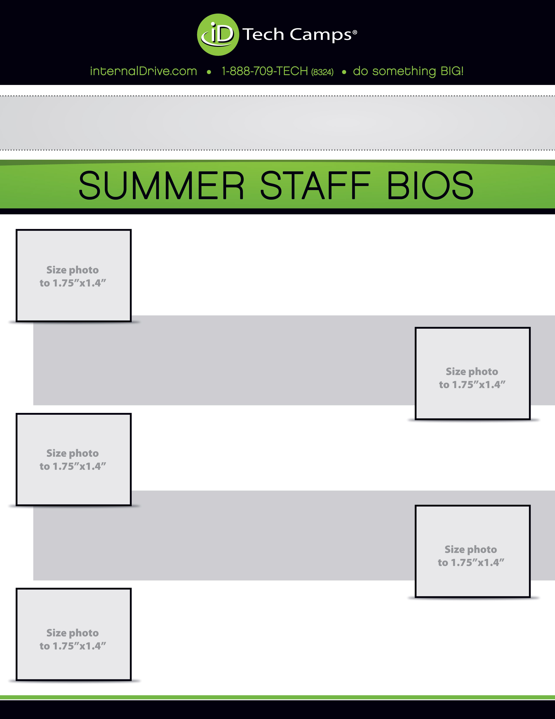*

**STAFF NICKNAME: STAFF POSITION:** Have each staff member write a 4 to 5 sentence biography in 3rd person. Make sure to add plenty of bragging rights. Parents are your audience and want to know their student is in talented and capable hands! Have each staff member write a 4 to 5 sentence biography in 3rd person.

**STAFF NICKNAME: STAFF POSITION:** Have each staff member write a 4 to 5 sentence biography in 3rd person. Make sure to add plenty of bragging rights. Parents are your audience and want to know their student is in talented and capable hands! Have each staff member write a 4 to 5 sentence biography in 3rd person.

**STAFF NICKNAME: STAFF POSITION:** Have each staff member write a 4 to 5 sentence biography in 3rd person. Make sure to add plenty of bragging rights. Parents are your audience and want to know their student is in talented and capable hands! Have each staff member write a 4 to 5 sentence biography in 3rd person.

**STAFF NICKNAME: STAFF POSITION:** Have each staff member write a 4 to 5 sentence biography in 3rd person. Make sure to add plenty of bragging rights. Parents are your audience and want to know their student is in talented and capable hands! Have each staff member write a 4 to 5 sentence biography in 3rd person.

**STAFF NICKNAME: STAFF POSITION:** Have each staff member write a 4 to 5 sentence biography in 3rd person. Make sure to add plenty of bragging rights. Parents are your audience and want to know their student is in talented and capable hands! Have each staff member write a 4 to 5 sentence biography in 3rd person.

**STAFF NICKNAME: STAFF POSITION:** Have each staff member write a 4 to 5 sentence biography in 3rd person. Make sure to add plenty of bragging rights. Parents are your audience and want to know their student is in talented and capable hands! Have each staff member write a 4 to 5 sentence biography in 3rd person.